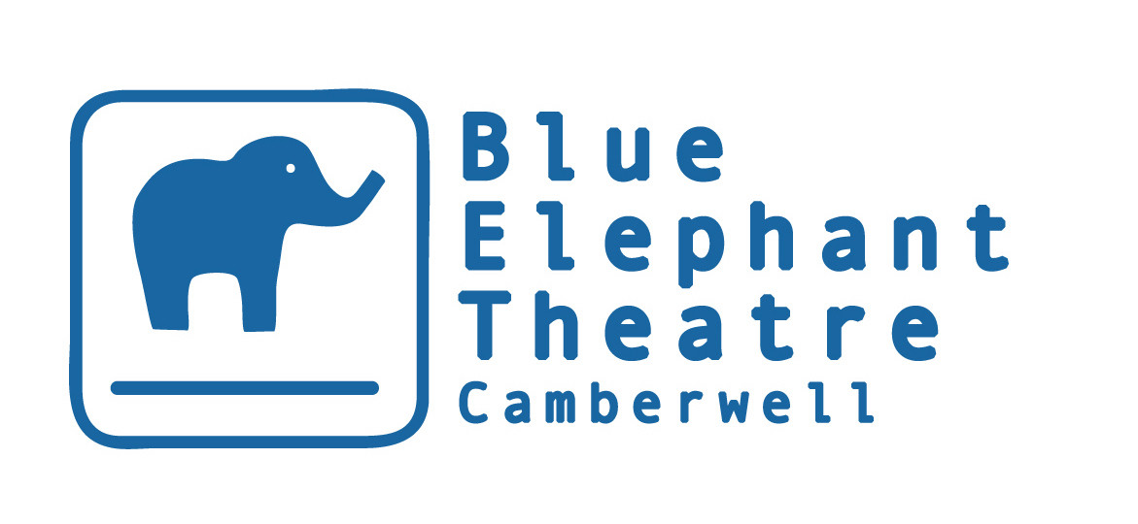
Development Officer

HISTORY & BACKGROUND

Opened in 1999, the Blue Elephant Theatre is a vibrant arts venue that aims to nurture new and emerging artists across all art-forms. Our varied programme includes dance, comedy, music, film and visual art alongside all forms of theatre while our participation department is far-reaching, innovative and accessible. We aim to link up both departments as often as possible. After a period of uncertainty, BET became an NPO in April 2018, making it an exciting time to work at the theatre.

Development Officer

Nature of the post
This is a new part-time role within the organisation, made possible by funding from the Evening Standard Dispossessed Fund: Save London Lives. Part Fundraiser/Community Liaison Officer, this role will work to support Blue Elephant Theatre to have a positive impact on discouraging young people locally from becoming involved in crime, particularly knife crime and gang related violence. The post-holder will do so by raising funds for projects, brokering and maintaining partnerships and relationships locally and working with Blue Elephant to evaluate our work in this area and identify room for development.

We have a goal of raising £50,000 over the year. This will feed directly into projects run in schools for disadvantaged young people and also to create opportunities for 18-25 year olds. We also expect this employee to create longer-term relationships and opportunities which can continue to be developed in the future to add stability to the organisation.

Blue Elephant Theatre currently receives core funding from Arts Council England and Southwark Council and has a successful track record of securing funding from trusts and grants and maintaining positive relationships with funders and other stakeholders so there is a strong basis on which to begin fundraising.

This is a flexible post and may suit an experienced fundraiser looking for a more varied project than usual or a youth worker or drama facilitator with some fundraising experience looking to develop these skills. A small amount of working from home will be possible although the post-holder will be expected to spend time in the office and to visit the various projects that we run locally and work alongside a variety of project leaders and volunteers, sharing knowledge and resources.

Salary £130 per day
Hours 55-60 days over one year
Holiday Entitlement Statutory
Probation Period 3 months
Pension Option to join our NEST pension scheme (auto-enrolment will also apply if earnings threshold is reached)

Reporting to Executive & Co-Artistic Director & Participation & Co-Artistic Director

Duties and Responsibilities

The successful candidate will work alongside our committed and ambitious team, to ​support their work with the local community and have a positive impact on ​reducing crime.

Specific Responsibilities:

Fundraising

*Fundraising will form the largest part of this role*

- Investigating BET’s suitability for potential funding opportunities
- Writing funding applications
- Ensuring reports are submitted by the deadlines given
- Seeking out new/creative ways to raise funds
- Raise £50,000 project funding (or alternatively agreed targets appropriate to the final agreement)
- Working alongside project staff to ensure that information for applications is accurate.

Project Support

- Visits to projects to become familiar with BET’s work
- Supporting evaluating the impact of projects
- Being a ‘critical friend’ to help identify areas we could develop to meet our aims

Relationship Building

- Seeking out partners and other contacts specific to developing this work
- Brokering meetings between BET project staff and contacts developed
- Developing and maintaining relationships with partners, stakeholders and other contacts

Other

- Act as Key holder, including responsibility for opening up and locking when required/agreed
- To actively promote equal opportunities
- Adhere to the theatre’s Health and safety policies
- To represent BET at networking events if necessary
- To undertake any other duties reasonably requested
- To support the implementation of BET’s Business plan, including its aim to be a safe space which supports the expression of creativity.

This safe space is:

- Somewhere artists can try new ideas, techniques and approaches, cushioned by BET’s support mechanisms.
- Somewhere local communities, particularly young people, feel safe to express themselves creatively and explore issues troubling them or that arise in their lives. At times, it is a safe space from troubles in their lives and BET staff take safeguarding young people and vulnerable adults extremely seriously.
- Somewhere inequality, discrimination and bullying is neither tolerated nor ignored. BET aims to set a standard for what it means to be a friendly, collaborative workplace which values employees, artists and other workers within BET alike.
- Somewhere audiences feel is “for them” regardless of their background and previous familiarity with the arts.

The Development Officer will share a responsibility to maintain and support this safe space. BET is committed to ensuring all employees find BET a safe space to work within and will give any grievances or concerns due attention.

The above list is not exhaustive and reasonable duties may be added to it especially as this is a new role.

Person Specification:

Essential
- Proven record of strong fundraising skills, especially with written applications. Please be prepared to discuss specific examples.
- A self-motivator, able to work independently
- Interest in the work of our charity, in particular work around keeping young people safe
- Excellent communication skills, including good grammar and spelling
- Interest in seeking out new/ creative ways to raise funds
- A quick learner
Desirable
- Knowledge of trusts and foundations relevant to our funding needs
- Experience of working with disadvantaged young people
- Experience of working to reduce crime amongst young people

As part of the application procedure, applicants should create a proposal/work plan considering their own commitments (eg a parent may want to work only during term-times) over the coming year alongside the needs of a successful fundraising plan.

We wish to see a brief work plan spanning one year from the start of the employment. The plan should include how you would use the hours for this post to make the most of the opportunity so that our income target is met. This could range from spreading out the days at regular intervals across the year, or working for shorter intense periods. Please indicate why you feel that this work plan will be successful and enable you to meet targets.

To apply: Please send us your CV, a covering letter detailing why you would like the role, your suitability for it and brief work plan to recruitment@blueelephanttheatre.co.uk. Please also download and complete a monitoring form ​and ​attach this to your email. Please note the final agreement on targets will be made with the successful applicant – we feel that the above is indicative of what is realistic and appropriate but that it is best to set targets etc with the post-holder.

The Blue Elephant Theatre welcomes applications from all sections of the community regardless of race, colour, ethnic or national origins, marital status, sex, sexual orientation, disability or religious beliefs.

