**Performance Call-Out**

We are looking for shows which represent & platform disabled artists!



There will be a £600 fee.

They will be on at Blue Elephant Theatre.

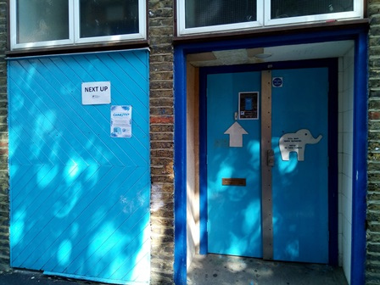

The performance space looks like this:

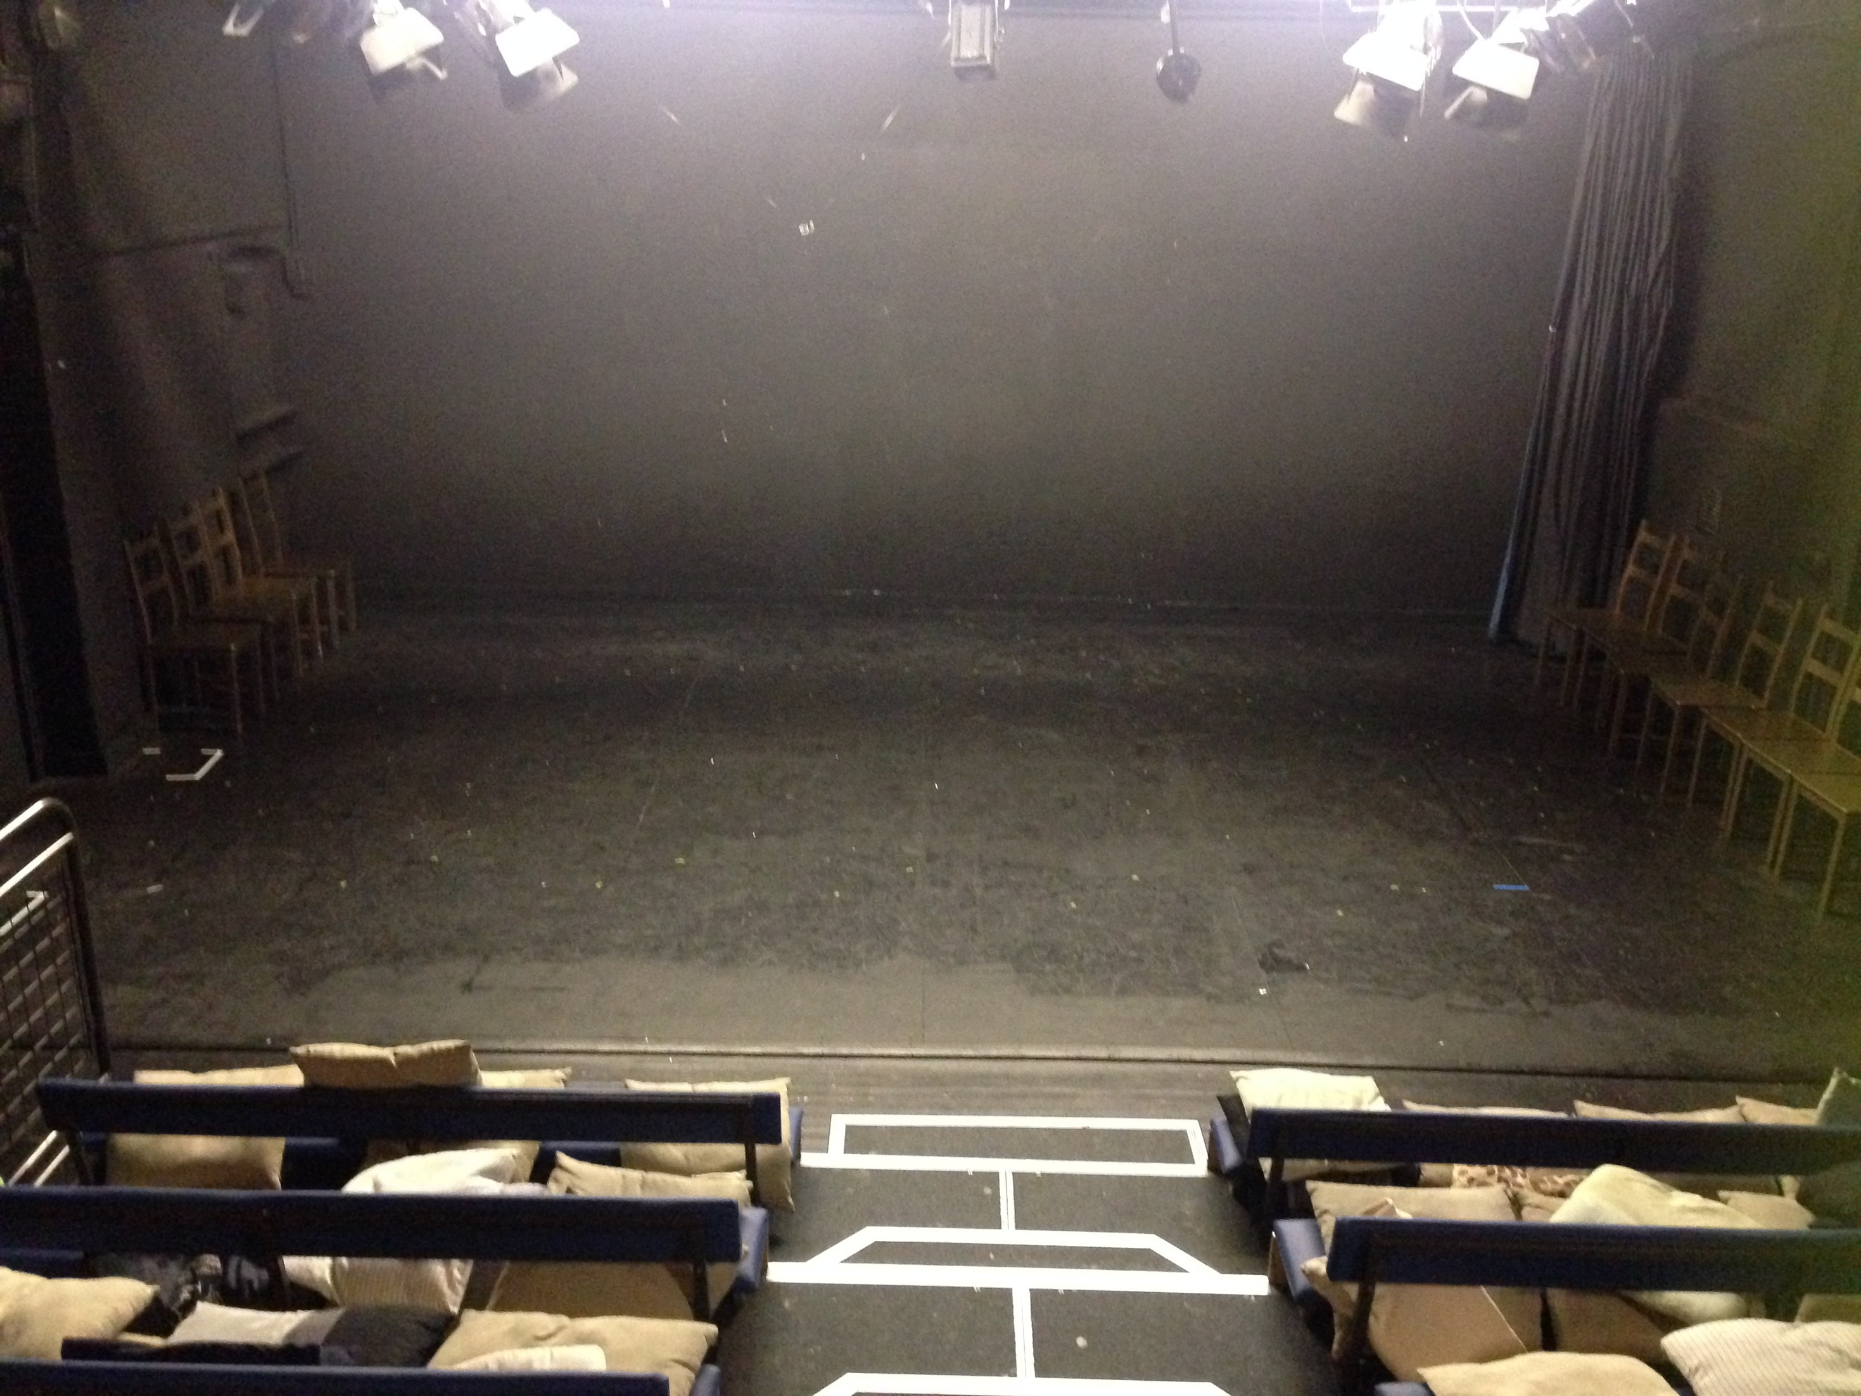

The seating looks like this and can fit 50 audience members:

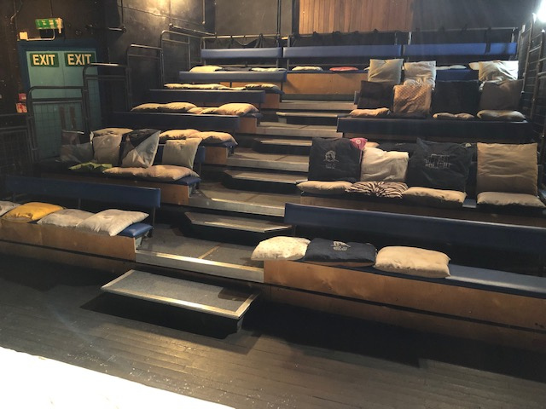

More information about the theatre can be found [here](http://blueelephanttheatre.co.uk/companies)



The shows will be on in March 2025.

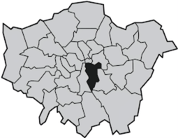Shows should have a link with Southwark, eg artists live, work or study there.



Our Youth Board will choose the shows. You may be invited to meet them on Friday November 1st.

To apply, please fill in the form below

and email it to [submissions@blueelephanttheatre.co.uk](mailto:submissions@blueelephanttheatre.co.uk).

Or submit a video or voice note to [submissions@blueelephanttheatre.co.uk](mailto:submissions@blueelephanttheatre.co.uk).

c175ffef-9c87-4afd-86b5-fb37ed836759.png



Please apply by 10am on October 23rd.





**Expression of Interest Form**

|  |  |
| --- | --- |
| **Name of Applicant (Artist or Company):** |  |
| **Lead Applicant (if applicable):** |  |
| **Contact details:** |  |
| **Email address:** |  |
| **Phone Number:** |  |
| **Title of Proposed Piece:** |  |

|  |
| --- |
| **Tell us about your piece and how it meets the brief:** |
|  |

|  |
| --- |
| **What technical requirements does it have?** |
|  |

|  |
| --- |
| **Do you have any footage of the piece? Please share a link if so.** |
|  |

|  |
| --- |
| **How are you connected to Southwark?** |
|  |

|  |
| --- |
| **Which dates in March 2025 are possible for you?** |
|  |

|  |
| --- |
| **What access needs does the team involved in the show have?** |
|  |

|  |
| --- |
| **How did you hear about this opportunity?** |
|  |

