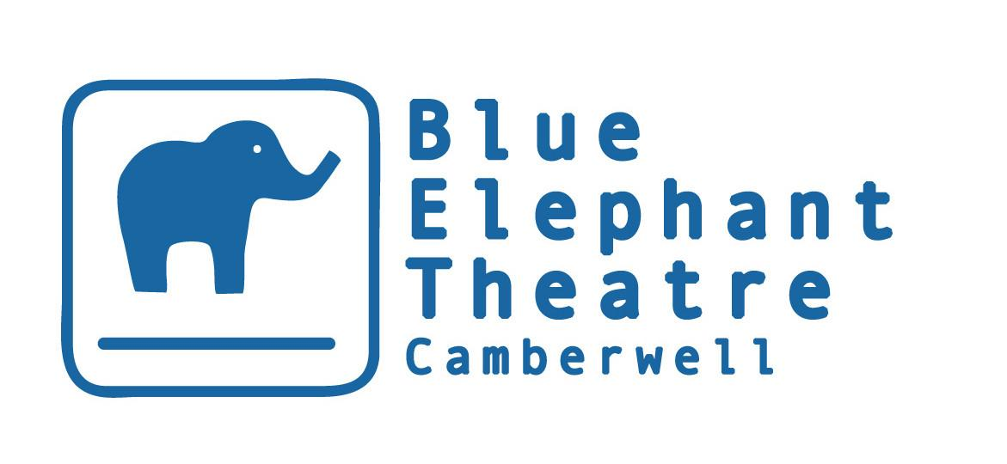

TECHNICAL MANAGER

HISTORY & BACKGROUND

Opened in 1999, the Blue Elephant Theatre is a vibrant arts venue that aims to widen access to creative opportunities and thus the benefits and positive impact of the arts. We have vibrant and engaging professional and participation departments and aim to link up both as often and meaningfully as possible. BET became an NPO in April 2018 and has been supported by Southwark Council since it opened.

Nature of the post
This role at Blue Elephant Theatre is made possible by National Portfolio Funding.

Contract

Salary £12.50 per hour
Hours 20 hours month as a minimum. Potentially significant additional hours will be offered most months at the same hourly rate.
Holidays Holiday entitlement will be of a statutory nature
Probation Three months

Reporting to: Theatre Manager & Programmer

Responsible for: Casual technicians

Duties and Responsibilities

- Maintaining BET's technical equipment and arranging for repairs if necessary
- Placing orders and ensuring technical stock levels are maintained
- Carrying out annual pat-testing (training will be arranged if necessary) and arranging for hire/borrowing of pat-testing machine
- Supporting get-ins
- Arranging for freelance technicians to cover get-ins the TM can't do and ensuring they are familiar with BET's equipment and the needs of the company
- Liaising with all companies ahead of their get-ins, ideally scheduling a phone call or meeting with the main technical contact in advance of the get-ins
- Liaising with hires ahead of their time at BET
- Ensuring companies know what they need to do as part of their get-out
- Being technician and operator for scratch nights, most in-house work and participation showcases. Supporting get-in, tech and potentially operating our in-house Christmas show.
- Keeping the Tech Spec and plan of the general wash up to date and available to incoming companies
- Ensuring companies complete risk assessments
- Rigging and derigging lights
- Some small general maintenance and repair jobs
- Being a key-holder at BET and being responsible for opening up and locking up within working hours when needed.
- To support the implementation of BET’s Business plan, including its aim to be a safe space which supports the expression of creativity.

This safe space is:

- Somewhere artists can try new ideas, techniques and approaches, cushioned by BET’s support mechanisms.
- Somewhere local communities, particularly young people, feel safe to express themselves creatively and explore issues troubling them or that arise in their lives. At times, it is a safe space from troubles in their lives and BET staff take safeguarding young people and vulnerable adults extremely seriously.
- Somewhere inequality, discrimination and bullying is neither tolerated nor ignored. BET aims to set a standard for what it means to be a friendly, collaborative workplace which values employees, artists and other workers within BET alike.
- Somewhere audiences feel is “for them” regardless of their background and previous familiarity with the arts.

The Technical Manager will share a responsibility to maintain and support this safe space. BET is committed to ensuring all employees find BET a safe space to work within and will give any grievances or concerns due attention.

Please note the above list is not exhaustive - it may evolve over time and reasonable duties may be added to it.

We aim to make this role as flexible as possible and to work with the post holder to schedule get-ins etc that suit their availability with good advance notice. Ideally - after the first few months - the post-holder will be able to cover approximately 50% of our get-ins. The post-holder must note however that some practical work will be limited to normal working hours so that a first aider is present in the building at this time. Please note that there is statutory holiday entitlement and that the Blue Elephant tends not to have shows in August so would be understanding if the post-holder planned to go to the Edinburgh Fringe.

The Blue Elephant Theatre welcomes applications from all sections of the community regardless of race, colour, ethnic or national origins, marital status, sex, sexual orientation, disability or religious beliefs.

Blue Elephant Theatre is committed to widening access to the arts and when recruiting we reserve the right to guarantee interviews to applicants referred by partner organisations provided they meet the essential criteria and complete an application form.

Please note BET's theatre space is wheelchair accessible but our office upstairs is not. We do not want this to deter potential applicants as we would seek to work together to find a practical working solution should the person appointed be a wheelchair user.

To apply, please fill out the application form below – or you can record your answers if you would prefer. Please share footage/recording via wetransfer/google drive links if possible. Applications should be emailed to recruitment@blueelephanttheatre.co.uk. If you have any questions or would like a more accessible way of applying, please email guillaume@blueelephanttheatre.co.uk or call 02077010100.
Technical Manager Application Form

Please complete the form below and send it to recruitment@blueelephanttheatre.co.uk by midday on 26 August 2022. Please include “Technical Manager Application” in the subject line. Alternatively, you can record your answers if you would prefer, although please keep this no more than seven minutes in length. Please share footage/recording via wetransfer/google drive links if possible to the same email address. Please follow this link to complete a monitoring form which is also requested by 26 August 2022.

Name:

Address:

Phone number:

Email address:

Have you the right to work in the UK?

Education
Please give details of your formal education, i.e. any schools and college/university you attended (You can also attach a CV instead to give these details)

Dates | Establishment | Courses/Subjects | Qualification/Grades

Do you have any other relevant training/skills?

Relevant work experience
Please begin with your current or most recent employment. Please include any volunteering or work experience that you feel is relevant. (You can also attach a CV instead to give these details)

Name & Address of Employer | Title of Role and Duties | Dates | Part-time/Full-time

Do you need to give notice before beginning this new job?
If so, how long is the notice period?

Statement: Please write a statement of up to 600 words, with reference to the person specification and job description, explaining why you feel you are suited to the position

Referees
Please provide names and addresses of two references, one of whom should be your current or most recent employer. Please indicate if references may be taken up prior to a job offer.

Referee One | Referee Two
Can be contacted prior to job offer? Y/N | Can be contacted prior to job offer? Y/N

Should you be invited to interview, do you have any access requirements?* If so, please detail:

Interviews will be held the week commencing 5 September 2022. Please outline below your availability that week.

Under the Rehabilitation of Offenders Act 1976, are there any convictions which you are required to disclose?

Declaration
I declare that the information contained in this application is correct to the best of my knowledge and understand that any false statement may result in my application being withdrawn or my appointment being terminated.

Signed: Date:

